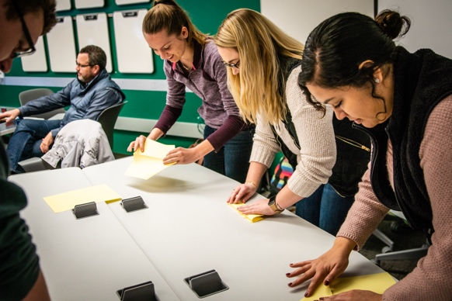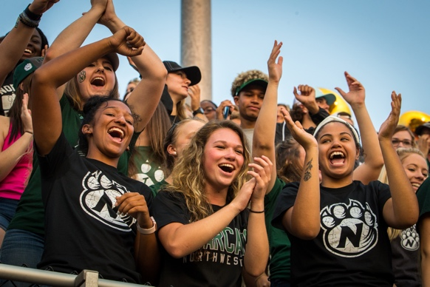

Click twice and type your info here. Use this font for most important details like date and time. Highlight and start typing!

Use this font for less important details like a paragraph of information.

**Type Title Here**